WAYNE COUNTY MUNICIPAL COURT

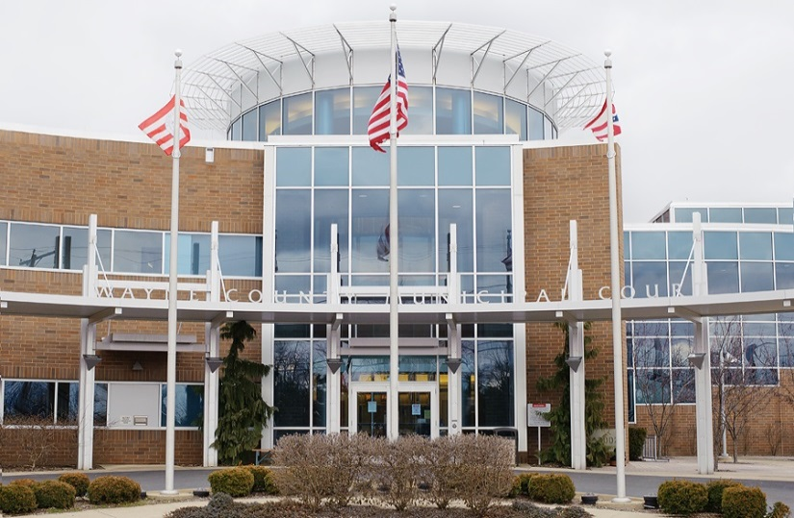
2020 Statistics

WAYNE COUNTY MUNICIPAL COURT
Personnel 2020

Timothy R. VanSickle Administrative Judge
Michael W. Rickett Presiding Judge
______________________________________________________________________________
Judge’s Staff
Nathan R. Shaker Magistrate
Karl Kubb Court Administrator
Terri Boreman Assignment Commissioner Holly Hughes Court Secretary
Gale Greegor Court Secretary Tom Anderson Bailiff
Dennis Felter Court Security/Bailiff
Stephanie Farley Court Security/Bailiff
Gregory Bolek Court Security/Bailiff
Curtiss Ricker Bailiff
Albert Hartzler IT Administrator
Denise Favalon Court Secretary
Michele Hobart Home Arrest Supervisor
Joseph Taylor Senior Home Arrest Officer
David Baney Probation Officer
David Baney Chief Probation Officer
James DeFelice Probation Officer
Robert Ecker Probation Officer
Justin McGrath Probation Officer
John Bridger Probation Officer
Jen Haven Probation Secretary

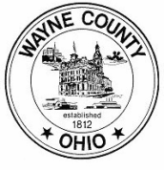

WAYNE COUNTY MUNICIPAL COURT
Personnel Changes 2020

● David Baney was promoted to Chief Probation Officer on January 13, 2020.
- Greg Bolek resigned from his position on January 24, 2020.
- Curtiss Ricker was hired to replace Greg Bolek on May 18, 2020.

WAYNE COUNTY MUNICIPAL COURT
Bailiffs 2020

In 2020, the Municipal Court employed four bailiffs, two courtroom bailiffs and two court security bailiffs.

The courtroom bailiffs are responsible for security in the courtrooms, monitoring the daily courtroom calendars, and ensuring the proper function of the digital recording systems within the courtrooms. The security bailiffs are responsible for the security of the courthouse and all offices within the courthouse. Security bailiffs operate a metal detector and scanner at the front entrance, secure the building at the beginning and end of each business day, and are responsible for the operation and maintenance of the security cameras and video recording system.

In addition, all four bailiffs serve the process of the court. This includes personal service of summons and orders, eviction notices and actual set outs, and executions on personal property including conducting bailiff sales.

WAYNE COUNTY MUNICIPAL COURT

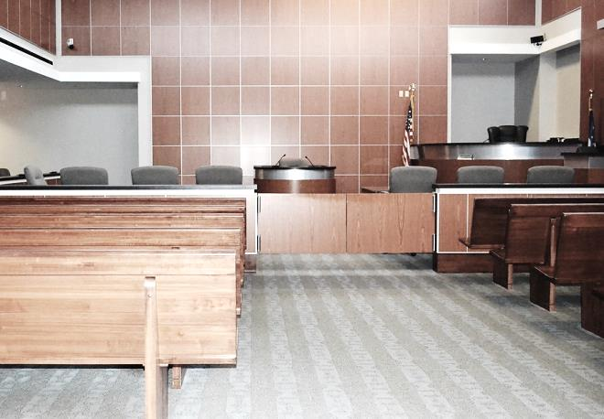
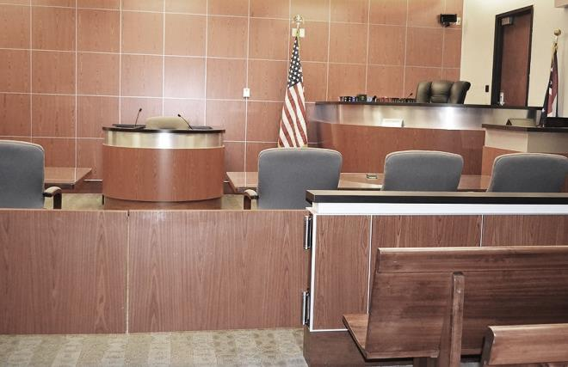
2020 Case Statistics

WAYNE COUNTY MUNICIPAL COURT
Cases Filed and Disposed 2020

Cases Filed 2019 2020

Criminal – Felony 65 15

Criminal – Misdemeanor 1,639 1,408

D.W.I. 280 292

Traffic 11,315 6,897

Civil 1,980 1,350

Small Claims 459 312

Total Cases Filed 15,738 10,274

Total Cases Disposed 14,026 9,093

* Cases disposed include waivers, defaults, pleas in court, and assignment to judge when not guilty plea (criminal, traffic) or answer (civil) is entered.

WAYNE COUNTY MUNICIPAL COURT
Cases Assigned for Trial 2020

Not Guilty Plea (Criminal – Traffic) or Answer (Civil)

2019 2020

Criminal – Misdemeanors 949 822

D.W.I. 211 204

Other Traffic 494 421

Civil-Small Claims 117 69

Total 1,771 1,516

Trials To Court

Criminal 30 31

D.W.I. 2 3

Other Traffic 51 44

Civil 0 0

Total 83 78

Jury Trials

Criminal 12 13

D.W.I. 0 1

Other Traffic 0 0

Civil 0 0

Total 12 14

WAYNE COUNTY MUNICIPAL COURT

2020 Payouts & Disbursements

WAYNE COUNTY MUNICIPAL COURT
Disbursements: Paid to Wayne County 2020

2019 2020

Paid to A13-N1 & A15-F1 669,788.32 506,921.42
Criminal-Traffic 290,707.01 198,554.56
Civil-Small Claims 157,792.27 107,361.86
OSP, State and Others 221,289.04 201,005.00

Paid to A13-G1 Housing/DUI 12,979.75 12,548.60

Paid to A13-S1 Restitution Fee 1,277.14 987.92

Paid to A13-Z1 Driving Privilege Fee 1,940 1,690

Paid to B18-A Diversion Program (Prosecutor) 13,950 12,000

Paid to B15-A1 Alcohol Treatment 21,128.40 20,333.42

Paid to B25-A1 Municipal IDIAF 10,648.81 10,393.42

Paid to K1-A3 Roads and Bridges 45,762.88 36,363.53

Paid to B1-A6 Dog and Kennel Fund 6,689.32 5,647.50

Paid to B16-A1 Education Fund 250.71 319.19

Paid to A42-C1 from sale of UTC 56.50 259.90

Paid to A45-O1 Misc. Reimbursements 15.85 0

Paid to B53-A1 Special Projects Fees* 44,895.50 121,616.40

Paid to B20-A1/A2 Computer Funds 182,982.95 117,760.02

Paid to B12-A1 Probation Fees 200,302.89 187,120.06

Paid to W35-A2 Indigent Application 7,191.82 6,764.18

Paid to A13-T1 Home Arrest Fees 50,330.50 51,365.50

Total $1,270,191.20 $1,092,090.90

*On August 1, 2019, the Special Projects Fund was created for Special Projects of the Wayne County Municipal Court pursuant to Ohio Revised Code Section R.C. 1901.26(B)(1).

WAYNE COUNTY MUNICIPAL COURT
Disbursements: Paid to State of Ohio 2020

2019 2020

Ohio State Patrol Fines 172,547.13 120,144.97

Victims of Crime 92,330.07 58,983.65

General Revenue* 0 0

Expungement Fees 2,268 2,010

Dept. of Liquor 4,963.05 4,326.71

Division of Wildlife 2,639 3,023.09

Legal Aid from Civil 50,630.07 34,517.34

Legal Aid from Small Claims* 5,007.87 3,408.57

Seat Belt Fines 48,432.20 29,262.10

Child Safety Fund 950 427

OSP Drug Fines 3,192.73 3,109

OSP Education Fund 4,123.02 3,752.94

Ohio Board of Pharmacy 12,144.86 10,215.24

Grant Refunds 17,807.26 0

BMV Fees 78.58 26.42

Totals $417,113.84 $273,207.03

Indigent Defense Support Fund $285,827.50 $192,023.10

$702,941.34 $465,230.13

* In 2010, per the Clerk of Courts, this account was consolidated into the Indigent Defense Support Fund (IDSF) for disbursements to the Treasurer of the State.
* On February 1, 2014, the Clerk of Courts assumed responsibility of the Small Claims Bank Account.

WAYNE COUNTY MUNICIPAL COURT
Disbursements: Drug Fines 2020

2019 2020

Creston 0 0

Chippewa Township 100 543.49

Dalton 100 0

Doylestown 183.28 369.92

Medway 100 100

Ohio State Police 0 100

Orrville 2,713.39 1,765.70

Paint Township 0 0

Rittman 0 413.30

Shreve 22.30 0

Smithville 0 0

Wayne County Sheriff 2,933.40 1,818.86

West Salem 350 0

Wooster 5,853.86 1,865.76

Village of Apple Creek 0 520

Total $12,356.23 $7,497.03

WAYNE COUNTY MUNICIPAL COURT
Paid to the Wayne County Law Library 2020

2019 2020

OSP Fines 86,867.43 60,070.08

State Fines 44,776.75 35,678.03

From Traffic 31,769.30 33,769.71

From Non-Traffic 4,800 4,800

Dept. of Liquor Control 1,200 1,200

Townships 5,757.75 4,509.03

Municipal Ordinances:

Wooster 1,300 1,300
Orrville 750 750
Rittman 150 150
Burbank 182 1,324.25

Totals $177,553.23 $143,551.10

WAYNE COUNTY MUNICIPAL COURT
Paid to Cities and Villages 2020

2019 2020

Wooster 31,006.24 21,788.05

Orrville 3,931.30 2,952

Rittman 17,200.50 9,281.70

Dalton 3,795.50 2,715.50

Apple Creek 1,906 1,528

West Salem 350 375

Mt. Eaton 1,262 391

Shreve 456.50 445

Smithville 175 150

Creston 1,189 1,337

Doylestown 35 0

Marshallville 100 40

Burbank 5,990.15 1,334.25

Total $67,397.19 $42,337.50

WAYNE COUNTY MUNICIPAL COURT
Disbursements: Other Fines and Fees 2020

2019 2020

Court of Appeals 500 250

Humane Society 0 0

Chippewa Township 5,757.75 3,860.03

Sheriff Fees 8,399.44 11,554.51

Wooster Police Fees 4,063.48 4,037.80

Creston Police Fees 211 60

Doylestown Police Fees 262.80 71

Orrville Police Fees 225.70 347.30

Rittman Police Fees 276.83 2,334.68

Smithville Police Fees 86 342.30

Shreve Police Fees 23 0

All Other Misc. Fees 498 1,480.57

Credit Card Fees 36,667.72 0

Totals $56,971.72 $24,338.19

WAYNE COUNTY MUNICIPAL COURT

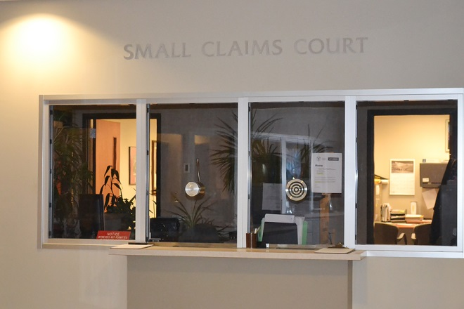
2020 Small Claims Court Statistics

WAYNE COUNTY MUNICIPAL COURT
Small Claims Court 2020

Small Claims Court handles monetary claims up to $6,000.00. All Small Claims cases are initially scheduled for a pre-trial mediation hearing. In 2020, there were 312 Small Claims cases filed. Sixteen (16) cases went to trial, resulting in a 95% mediation settlement rate.

In addition to processing complaints, the Small Claims staff assists judgment creditors with post judgment collection actions. These include wage garnishments, attachments, executions on property and conducting judgment debtor exam hearings.

2020 filings by location:

Wooster 312

*Due to numerous reasons, on March 1, 2020, the Municipal Court ceased operating at its Orrville Branch.

WAYNE COUNTY MUNICIPAL COURT

2020 Probation & Home Arrest Statistics

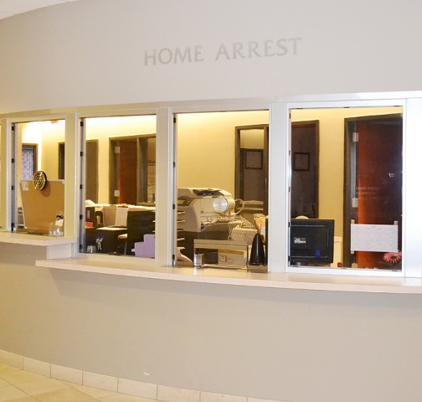
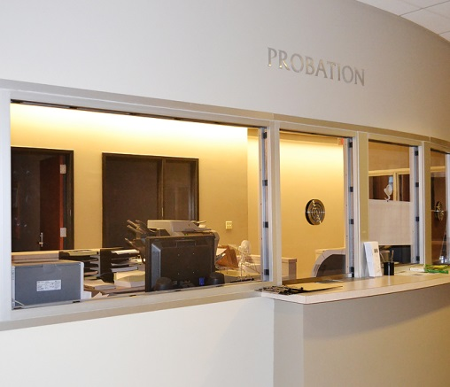

WAYNE COUNTY MUNICIPAL COURT
Probation Department 2020

2019 2020

Pre-Sentence Investigations 230 173

Placed on Probation 723 635

Released from Probation 706 686
Probation Violations 346 226

Expungement Investigations 119 92

Community Service Hours 9,257.30 1,923.29

Probation Fees Collected $200,302.89 $187,120.06

1st Offense DUI Program

Placed on Probation 49 77

Probation Violations 26 28

Released from Probation N/A 61

WAYNE COUNTY MUNICIPAL COURT
Home Arrest Department 2020

2019 2020

Placed on Home Arrest 256 211

Number of Days Served 10,892 11,616

Number of Violations 18 14

Home Arrest Receipts

Total Paid to Wayne County $112,747 $112,748

Received from State CCA Grant* $225,496 $225,496

* The CCA 408 Electronic Monitoring Grant funds Home Arrest employees (salaries and benefits).

At the 2020 rate of $89.75 (the cost to house one inmate per day at the Wayne County Jail in 2020), the Home Arrest department saved a total of $1,042,536.00 in inmate per day, jail costs.

WAYNE COUNTY MUNICIPAL COURT
Disbursements: DUI Fines, Law Enforcement & Education Fund 2020

2019 2020

Wooster 1,047.80 926.46

Orrville 290.39 227.41

Rittman 197.23 160.19

Dalton 25 25

Apple Creek 25 0

West Salem 0 50

Mt. Eaton 7 40.77

Shreve 0 35

Smithville 126.10 114.01

Creston 32.87 85

Doylestown 112.49 340.51

Chippewa Township 30.97 92.29

Ohio State University 0 0

Total $1,894.85 $2,096.64

