WAYNE COUNTY MUNICIPAL COURT

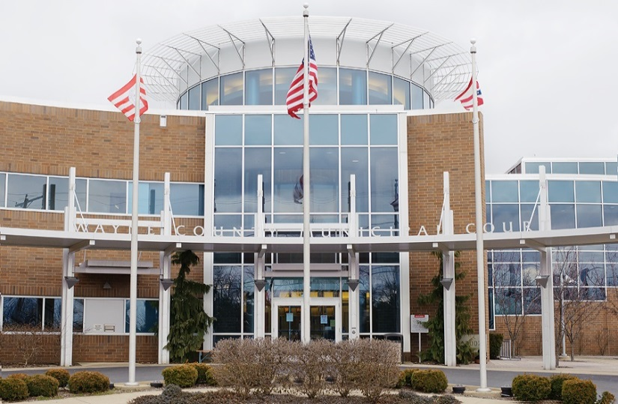
2019 Statistics

WAYNE COUNTY MUNICIPAL COURT
Personnel 2019

Michael W. Rickett Administrative Judge
Timothy R. VanSickle Presiding Judge
______________________________________________________________________________
Judge’s Staff
Nathan R. Shaker Magistrate
Karl Kubb Court Administrator
Ethan O’Neal Assignment Commissioner
Terri Boreman Assignment Commissioner Holly Hughes Court Secretary
Gale Greegor Court Secretary Tom Anderson Bailiff
Dennis Felter Court Security/Bailiff
Stephanie Farley Court Security/Bailiff
Gregory Bolek Court Security/Bailiff
Albert Hartzler IT Administrator
Denise Favalon Court Secretary
Michele Hobart Home Arrest Supervisor
Joseph Taylor Senior Home Arrest Officer
Michael Matej Home Arrest Officer
Angela Schaad Chief Probation Officer Jim DeFelice Probation Officer
David Baney Probation Officer
Michelle Oney Probation Officer
Robert Ecker Probation Officer
Justin McGrath Probation Officer
John Bridger Probation Officer
Jen Haven Probation Secretary

WAYNE COUNTY MUNICIPAL COURT
Personnel Changes 2019

● Angela Schaad passed away on 1/24/19.
- Michelle Oney resigned from her position on 4/26/19.
- Robert Ecker was hired to replace Michelle Oney on 7/8/19.
- Ethan O’Neal resigned from his position on 8/12/19.
- Michael Matej was terminated from his position on 8/30/19.
- Terri Boreman was hired to replace Ethan O’Neal on 9/30/19.

WAYNE COUNTY MUNICIPAL COURT
Bailiffs 2019

In 2019, the Municipal Court employed four bailiffs, one courtroom bailiff and three court security bailiffs.

The courtroom bailiff is responsible for security in the courtrooms, monitoring the daily courtroom calendars, and ensuring the proper function of the digital recording systems within the courtrooms. The security bailiffs are responsible for the security of the courthouse and all offices within the courthouse. Security bailiffs operate a metal detector and scanner at the front entrance, secure the building at the beginning and end of each business day, and are responsible for the operation and maintenance of the security cameras and video recording system.

In addition, all four bailiffs serve the process of the court. This includes personal service of summons and orders, eviction notices and actual set outs, and executions on personal property including conducting bailiff sales.

WAYNE COUNTY MUNICIPAL COURT

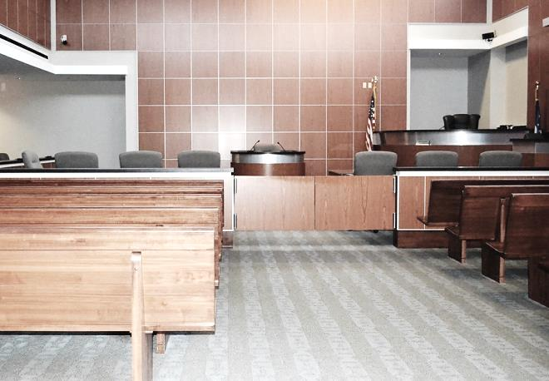
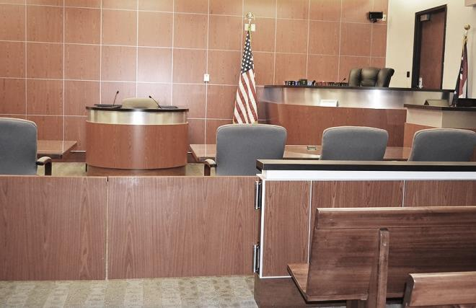
2019 Case Statistics

WAYNE COUNTY MUNICIPAL COURT
Cases Filed and Disposed 2019

Cases Filed 2018 2019

Criminal – Felony 64 65

Criminal – Misdemeanor 2,100 1,639

D.W.I. 362 280

Traffic 11,462 11,315

Civil 2,024 1,980

Small Claims 440 459

Total Cases Filed 16,452 15,738

Total Cases Disposed 14,663 14,026

* Cases disposed include waivers, defaults, pleas in court, and assignment to judge when not guilty plea (criminal, traffic) or answer (civil) is entered.

WAYNE COUNTY MUNICIPAL COURT
Cases Assigned for Trial 2019

Not Guilty Plea (Criminal – Traffic) or Answer (Civil)

2018 2019

Criminal – Misdemeanors 1,305 949

D.W.I. 270 211

Other Traffic 572 494

Civil-Small Claims 103 117

Total 2,250 1,771

Trials To Court

Criminal 52 30

D.W.I. 4 2

Other Traffic 65 51

Civil 2 0

Total 123 83

Jury Trials

Criminal 7 12

D.W.I. 5 0

Other Traffic 0 0

Civil 0 0

Total 12 12

WAYNE COUNTY MUNICIPAL COURT

2019 Payouts & Disbursements

WAYNE COUNTY MUNICIPAL COURT
Disbursements: Paid to Wayne County 2019

2018 2019

Paid to A13-N1 & A15-F1 671,889.98 669,788.32
Criminal-Traffic 298,579.48 290,707.01
Civil-Small Claims 150,580.96 157,792.27
OSP, State and Others 222,729.54 221,289.04

Paid to A13-G1 Housing/DUI 12,900.22 12,979.75

Paid to B18-A Diversion Program (Prosecutor) 12,750 13,950

Paid to B15-A1 Alcohol Treatment 21,640.23 21,128.40

Paid to K1-A3 Roads and Bridges 49,259.69 45,762.88

Paid to B1-A6 Dog and Kennel Fund 2,778.78 6,689.32

Paid to B16-A1 Education Fund 617.98 250.71

Paid to A42-C1 from sale of UTC 1,004.65 56.50

Paid to A45-O1 Misc. Reimbursements 0 15.85

Paid to B53-A1 Special Projects Fees* 0 44,895.50

Paid to B20-A1/A2 Computer Funds 183,210 182,982.95

Paid to B12-A1 Probation Fees 135,694.67 200,302.89

Paid to W35-A2 Indigent Application 7,904.44 7,191.82

Paid to A13-T1 Home Arrest Fees 50,264.33 50,330.50

Total $1,149,914.90 $1,256,325.30

*On August 1, 2019, the Special Projects Fund was created for Special Projects of the Wayne County Municipal Court pursuant to Ohio Revised Code Section R.C. 1901.26(B)(1).

WAYNE COUNTY MUNICIPAL COURT
Disbursements: Paid to State of Ohio 2019
2018 2019

Ohio State Patrol Fines 167,241.08 172,547.13

Victims of Crime 93,821.14 92,330.07

General Revenue* 0 0

Expungement Fees 2,532 2,268

Dept. of Liquor 3,117.95 4,963.05

Division of Wildlife 3,977.91 2,639

Legal Aid from Civil 51,145.42 50,630.07

Legal Aid from Small Claims* 4,794.33 5,007.87

Seat Belt Fines 49,909.50 48,432.20

Child Safety Fund 525 950

OSP Drug Fines 2,639 3,192.73

OSP Education Fund 4,074.38 4,123.02

Ohio Board of Pharmacy 14,320.18 12,144.86

Grant Refunds 0 17,807.26

BMV Fees 60 78.58

Totals $398,157.89 $417,113.84

Indigent Defense Support Fund $291,336.59 $285,827.50

$689,494.48 $702,941.34

* In 2010, per the Clerk of Courts, this account was consolidated into the Indigent Defense Support Fund (IDSF) for disbursements to the Treasurer of the State.
* On February 1, 2014, the Clerk of Courts assumed responsibility of the Small Claims Bank Account.

WAYNE COUNTY MUNICIPAL COURT
Disbursements: Drug Fines 2019

2018 2019

Creston 0 0

Chippewa Township 148.80 100

Dalton 200 100

Doylestown 400 183.28

Medway 0 100

Ohio State Police 150 0

Orrville 2,629.30 2,713.39

Paint Township 0 0

Rittman 1,135 0

Shreve 0 22.30

Smithville 0 0

Wayne County Sheriff 5,490.10 2,933.40

West Salem 0 350

Wooster 7,969.11 5,853.86

Village of Apple Creek 250 0

Total $18,372.31 $12,356.23

WAYNE COUNTY MUNICIPAL COURT
Paid to the Wayne County Law Library 2019

2018 2019

OSP Fines 84,224.88 86,867.43

State Fines 48,659.03 44,776.75

From Traffic 35,714.5 31,769.30

From Non-Traffic 4,800 4,800

Dept. of Liquor Control 1,200 1,200

Townships 9,477.77 5,757.75

Municipal Ordinances:

Wooster 1,300 1,300
Orrville 750 750
Rittman 150 150
Burbank 0 182

Totals $186,276.43 $177,553.23

WAYNE COUNTY MUNICIPAL COURT
Paid to Cities and Villages 2019

2018 2019

Wooster 28,907.04 31,006.24

Orrville 5,934.50 3,931.30

Rittman 17,120.50 17,200.50

Dalton 4,561.71 3,795.50

Apple Creek 2,234 1,906

West Salem 107 350

Mt. Eaton 400 1,262

Shreve 0 456.50

Smithville 50 175

Creston 257 1,189

Doylestown 0 35

Marshallville 235 100

Burbank 5,664 5,990.15

Total $65,470.75 $67,397.19

WAYNE COUNTY MUNICIPAL COURT
Disbursements: Other Fines and Fees 2019

2018 2019

Court of Appeals 1,500 500

Humane Society 200 0

Chippewa Township 9,477.77 5,757.75

Sheriff Fees 8,547.56 8,399.44

Wooster Police Fees 3,786.67 4,063.48

Creston Police Fees 159 211

Doylestown Police Fees 249.20 262.80

Orrville Police Fees 452.20 225.70

Rittman Police Fees 889.40 276.83

Smithville Police Fees 85.38 86

Shreve Police Fees 30 23

All Other Misc. Fees 921.47 498

Credit Card Fees 0 36,667.72

Totals $26,298.65 $56,971.72

WAYNE COUNTY MUNICIPAL COURT

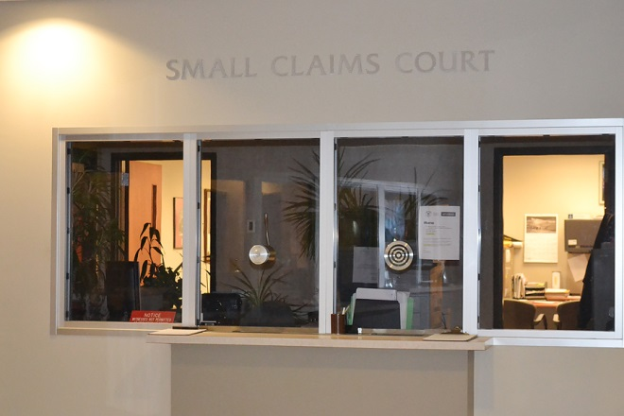
2019 Small Claims Court Statistics

WAYNE COUNTY MUNICIPAL COURT
Small Claims Court 2019

Small Claims Court handles monetary claims up to $6,000.00. All Small Claims cases are initially scheduled for a pre-trial mediation hearing. In 2019, there were 459 Small Claims cases filed. Thirty (30) cases went to trial, resulting in a 93% mediation settlement rate.

In addition to processing complaints, the Small Claims staff assists judgment creditors with post judgment collection actions. These include wage garnishments, attachments, executions on property and conducting judgment debtor exam hearings.

2019 filings by location:

Wooster 442

Orrville 17

*Due to numerous reasons, on March 1, 2020, the Municipal Court ceased operating at its Orrville Branch.

WAYNE COUNTY MUNICIPAL COURT

2019 Probation & Home Arrest Statistics

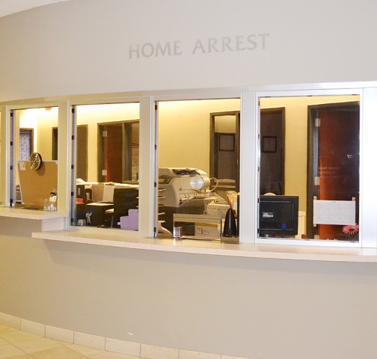
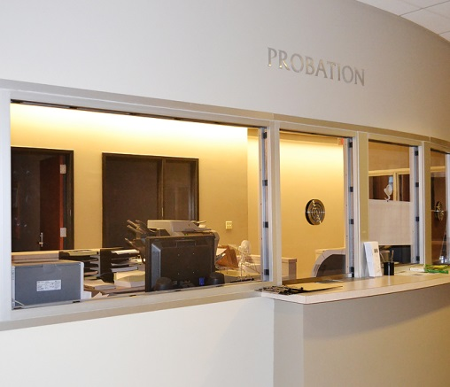

WAYNE COUNTY MUNICIPAL COURT
Probation Department 2019

2018 2019

Pre-Sentence Investigations 283 230

Placed on Probation 770 723

Released from Probation 596 706

Probation Violations 284 346

Expungement Investigations 99 119

Community Service Hours 6,338.91 9,257.30

Probation Fees Collected $135,694.67 $200,302.89

1st Offense DUI Program

Placed on Probation 113 49

Probation Violations 37 26

Released from Probation 133 N/A

WAYNE COUNTY MUNICIPAL COURT
Home Arrest Department 2019

2018 2019

Placed on Home Arrest 248 256

Number of Days Served 10,871 10,892

Number of Violations 31 18

Home Arrest Receipts

Total Paid to Wayne County $157,746 $112,747

Received from State CCA Grant* $225,492 $225,496

* The CCA 408 Electronic Monitoring Grant funds Home Arrest employees (salaries and benefits).

Additionally, Juvenile and Common Pleas Courts utilize our equipment and server as needed. This prevents these departments from paying vendor fees to outside agencies to operate their electronic monitoring programs.

- At the 2019 rate of $76.41 (the cost to house one inmate per day at the Wayne County Jail in 2019), the Home Arrest department saved a total of $832,257.72 in inmate per day, jail costs.

