WAYNE COUNTY MUNICIPAL COURT

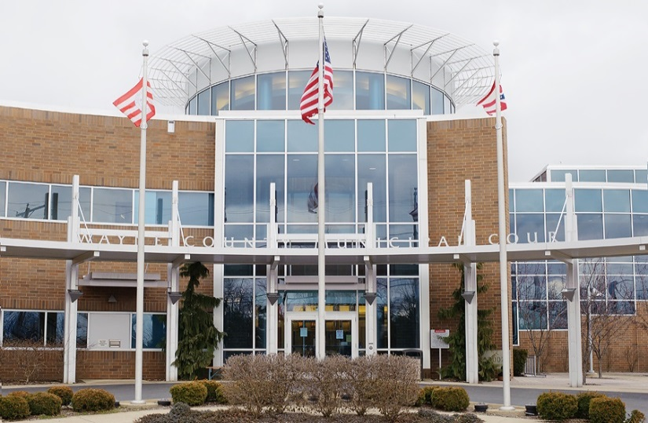
2021 Statistics

WAYNE COUNTY MUNICIPAL COURT
Personnel 2021

Michael W. Rickett Administrative Judge
Timothy R. VanSickle Presiding Judge
______________________________________________________________________________
Judge’s Staff
Nathan R. Shaker Magistrate
Karl Kubb Court Administrator
Terri Boreman Assignment Commissioner Holly Hughes Court Secretary/Jury Commissioner
Gale Greegor Court Secretary Tom Anderson Bailiff
Dennis Felter Court Security/Bailiff
Stephanie Farley Court Security/Bailiff
Curtiss Ricker Bailiff
Albert Hartzler IT Administrator
Denise Favalon Court Secretary
Michele Hobart Home Arrest Supervisor
Joseph Taylor Senior Home Arrest Officer
David Baney Chief Probation Officer
James DeFelice Probation Officer
Robert Ecker Probation Officer
Justin McGrath Probation Officer
Justin McGrath Senior Probation Officer
John Bridger Probation Officer
Natalie Martz Probation Officer
Jen Haven Administrative Assistant

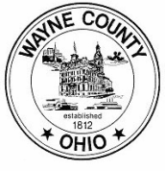

WAYNE COUNTY MUNICIPAL COURT
Personnel Changes 2021

● Gale Greegor unfortunately passed away on April 18, 2021.
- John Bridger retired on April 23, 2021.
- Natalie Martz was hired as a Probation Officer on August 16, 2021.
- Justin McGrath was promoted to Senior Probation Officer on October 24, 2021.

WAYNE COUNTY MUNICIPAL COURT
Bailiffs 2021

In 2021, the Municipal Court employed four bailiffs, two courtroom bailiffs and two court security bailiffs.

The courtroom bailiffs are responsible for security in the courtrooms, monitoring the daily courtroom calendars, and ensuring the proper function of the digital recording systems within the courtrooms. The security bailiffs are responsible for the security of the courthouse and all offices within the courthouse. Security bailiffs operate a metal detector and scanner at the front entrance, secure the building at the beginning and end of each business day, and are responsible for the operation and maintenance of the security cameras and video recording system.

In addition, all four bailiffs serve the process of the court. This includes personal service of summons and orders, eviction notices and actual set outs, and executions on personal property including conducting bailiff sales.

WAYNE COUNTY MUNICIPAL COURT

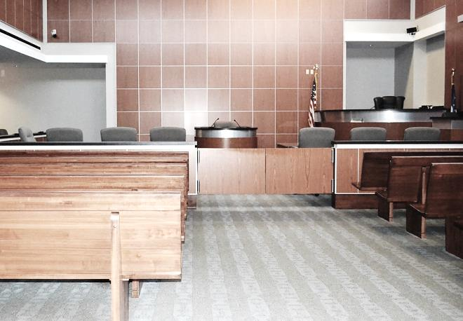
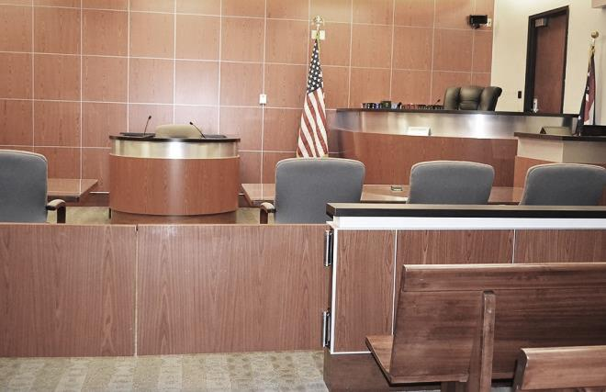
2021 Case Statistics

WAYNE COUNTY MUNICIPAL COURT
Cases Filed and Disposed 2021

Cases Filed 2020 2021

Criminal – Felony 15 6

Criminal – Misdemeanor 1,408 1,446

D.W.I. 292 288

Traffic 6,897 7,919

Civil 1,350 1,480

Small Claims 312 282

Total Cases Filed 10,274 11,421

Total Cases Disposed 9,093 10,057

* Cases disposed include waivers, defaults, pleas in court, and assignment to judge when not guilty plea (criminal, traffic) or answer (civil) is entered.

WAYNE COUNTY MUNICIPAL COURT
Cases Assigned for Trial 2021

Not Guilty Plea (Criminal – Traffic) or Answer (Civil)

2020 2021

Criminal – Misdemeanors 822 895

D.W.I. 204 207

Other Traffic 421 412

Civil-Small Claims 69 59

Total 1,516 1,573

Trials To Court

Criminal 31 43

D.W.I. 3 4

Other Traffic 44 37

Civil 0 0

Total 78 84

Jury Trials

Criminal 13 18

D.W.I. 1 6

Other Traffic 0 0

Civil 0 0

Total 14 24

WAYNE COUNTY MUNICIPAL COURT

2021 Payouts & Disbursements

WAYNE COUNTY MUNICIPAL COURT
Disbursements: Paid to Wayne County 2021

2020 2021

Paid to A13-N1 & A15-F1 506,921.42 555,240.37
Criminal-Traffic 198,554.56 217,175.98
Civil-Small Claims 107,361.86 114,367.15
OSP, State and Others 201,005.00 223,697.24

Paid to A13-G1 Housing/DUI 12,548.60 13,780.15

Paid to A13-S1 Restitution Fee 987.92 1,663.34

Paid to A13-Z1 Driving Privilege Fee 1,690 1,960

Paid to B18-A Diversion Program (Prosecutor) 12,000 8,550

Paid to B15-A1 Alcohol Treatment 20,333.42 18,714.36

Paid to B25-A1 Municipal IDIAF 10,393.42 11,434.64

Paid to K1-A3 Roads and Bridges 36,363.53 34,158.80

Paid to B1-A6 Dog and Kennel Fund 5,647.50 3,136.50

Paid to B16-A1 Education Fund 319.19 349.46

Paid to A42-C1 from sale of UTC 259.90 320

Paid to A45-O1 Misc. Reimbursements 0 655

Paid to B53-A1 Special Projects Fees* 121,616.40 142,127.30

Paid to B20-A1/A2 Computer Funds 117,760.02 132,524.69

Paid to B12-A1 Probation Fees 187,120.06 213,287.91

Paid to W35-A2 Indigent Application 6,764.18 8,204.70

Paid to A13-T1 Home Arrest Fees 51,365.50 59,504.70

Total $1,092,090.90 $1,205,611.90

*On August 1, 2019, the Special Projects Fund was created for Special Projects of the Wayne County Municipal Court pursuant to Ohio Revised Code Section R.C. 1901.26(B)(1).

WAYNE COUNTY MUNICIPAL COURT
Disbursements: Paid to State of Ohio 2021

2020 2021

Ohio State Patrol Fines 120,144.97 144,919.24

Victims of Crime 58,983.65 64,220.82

General Revenue* 0 0

Expungement Fees 2,010 2,280

Dept. of Liquor 4,326.71 3,929.43

Division of Wildlife 3,023.09 3,207.50

Legal Aid from Civil 34,517.34 37,661.69

Legal Aid from Small Claims* 3,408.57 3,049.20

Seat Belt Fines 29,262.10 41,811.93

Child Safety Fund 427 250

OSP Drug Fines 3,109 2,448.27

OSP Education Fund 3,752.94 4,855.27

Ohio Board of Pharmacy 10,215.24 9,678.52

Grant Refunds 0 11,490.12

BMV Fees 26.42 45

Totals $273,207.03 $329,846.99

Indigent Defense Support Fund $192,023.10 $213,873.86

$465,230.13 $543,720.85

* In 2010, per the Clerk of Courts, this account was consolidated into the Indigent Defense Support Fund (IDSF) for disbursements to the Treasurer of the State.
* On February 1, 2014, the Clerk of Courts assumed responsibility of the Small Claims Bank Account.

WAYNE COUNTY MUNICIPAL COURT
Disbursements: Drug Fines 2021

2020 2021

Creston 0 100

Chippewa Township 543.49 200

Dalton 0 425

Doylestown 369.92 0

Medway 100 100

Ohio State Police 100 0

Orrville 1,765.70 657.60

Paint Township 0 0

Rittman 413.30 152.83

Shreve 0 0

Smithville 0 0

Wayne County Sheriff 1,818.86 1,590.77

West Salem 0 100

Wooster 1,865.76 1,819.21

Village of Apple Creek 520 150

Total $7,497.03 $5,295.41

WAYNE COUNTY MUNICIPAL COURT
Paid to the Wayne County Law Library 2021

2020 2021

OSP Fines 60,070.08 72,330.98

State Fines 35,678.03 33,662.36

From Traffic 33,769.71 31,244.28

From Non-Traffic 4,800 4,800

Dept. of Liquor Control 1,200 1,200

Townships 4,509.03 5,668.01

Municipal Ordinances:

Wooster 1,300 1,300
Orrville 750 750
Rittman 150 150
Burbank 1,324.25 194

Totals $143,551.10 $151,299.63

WAYNE COUNTY MUNICIPAL COURT
Paid to Cities and Villages 2021

2020 2021

Wooster 21,788.05 26,783.25

Orrville 2,952 2,195

Rittman 9,281.70 6,646.05

Dalton 2,715.50 6,300.50

Apple Creek 1,528 1,695.65

West Salem 375 36

Mt. Eaton 391 712.50

Shreve 445 989.50

Smithville 150 30

Creston 1,337 175

Doylestown 0 54

Marshallville 40 0

Burbank 1,334.25 194

Fredericksburg 0 407.50

Total $42,337.50 $46,218.95

WAYNE COUNTY MUNICIPAL COURT
Disbursements: Other Fines and Fees 2021

2020 2021

Court of Appeals 250 750

Humane Society 0 150

Chippewa Township 3,860.03 5,260.53

Sheriff Fees 11,554.51 9,979.32

Wooster Police Fees 4,037.80 4,109.03

Creston Police Fees 60 184.50

Doylestown Police Fees 71 128.30

Orrville Police Fees 347.30 251.32

Rittman Police Fees 2,334.68 1,149.49

Smithville Police Fees 342.30 315.80

Shreve Police Fees 0 0

Apple Creek Police Fees 45 127
All Other Misc. Fees 1,435.57 1,016.58

Credit Card Fees 0 0

Totals $24,338.19 $23,421.87

WAYNE COUNTY MUNICIPAL COURT

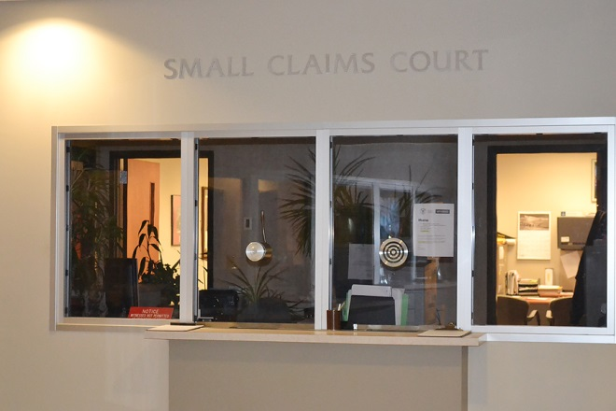
2021 Small Claims Court Statistics

WAYNE COUNTY MUNICIPAL COURT
Small Claims Court 2021

Small Claims Court handles monetary claims up to $6,000.00. All Small Claims cases are initially scheduled for a pre-trial mediation hearing. In 2021, there were 282 Small Claims cases filed. Twenty-seven (27) cases went to trial, resulting in an approximately 90% mediation settlement rate.

In addition to processing complaints, the Small Claims staff assists judgment creditors with post judgment collection actions. These include wage garnishments, attachments, executions on property and conducting judgment debtor exam hearings.

2021 filings by location:

Wooster 282

*Due to numerous reasons, on March 1, 2020, the Municipal Court ceased operating at its Orrville Branch.

WAYNE COUNTY MUNICIPAL COURT

2021 Probation & Home Arrest Statistics

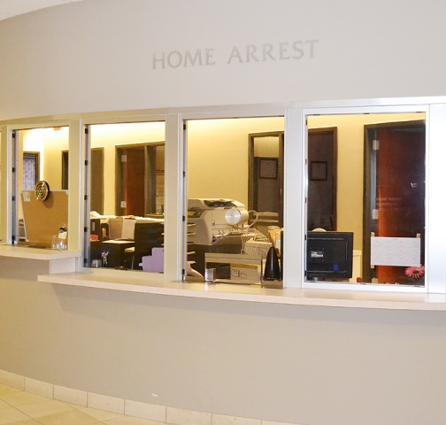
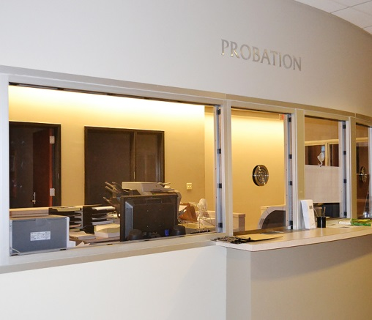

WAYNE COUNTY MUNICIPAL COURT
Probation Department 2021

2020 2021

Pre-Sentence Investigations 173 167

Placed on Probation 635 632
Released from Probation 686 765
Probation Violations 226 264
Expungement Investigations 92 121
Community Service Hours 1,923.29 519.33

Probation Fees Collected $187,120.06 $213,287.91

1st Offense DUI Program

Placed on Probation 77 76
Probation Violations 28 13
Released from Probation 61 66

WAYNE COUNTY MUNICIPAL COURT
Home Arrest Department 2021

2020 2021

Placed on Home Arrest 211 207

Number of Days Served 11,616 10,243
Number of Violations 14 16
Home Arrest Receipts

Total Paid to Wayne County $112,748 $112,748

Received from State CCA Grant* $225,496 $225,496

* The CCA 408 Electronic Monitoring Grant funds Home Arrest employees (salaries and benefits).

At the 2021 rate of $90.60 (the cost to house one inmate per day at the Wayne County Jail in 2021), the Home Arrest department saved a total of $928,015.80 in inmate per day, jail costs.

WAYNE COUNTY MUNICIPAL COURT
Disbursements: DUI Fines, Law Enforcement & Education Fund 2021

2020 2021

Wooster 926.46 970.60

Orrville 227.41 133.64

Rittman 160.19 295

Dalton 25 19.45

Apple Creek 0 0

West Salem 50 95

Mt. Eaton 40.77 0

Shreve 35 50

Smithville 114.01 25

Creston 85 34.60

Doylestown 340.51 127.57

Chippewa Township 92.29 281.15

Ohio State University 0 0

Total $2,096.64 $2,032.01

