WAYNE COUNTY MUNICIPAL COURT

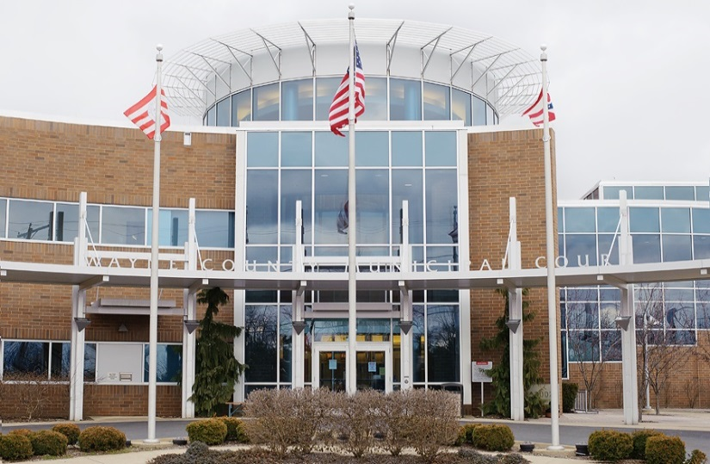
2022 Statistics

WAYNE COUNTY MUNICIPAL COURT
Personnel 2022

Timothy R. VanSickle Administrative Judge
Michael W. Rickett Presiding Judge
______________________________________________________________________________
Judge’s Staff
Nathan R. Shaker Magistrate
Karl Kubb Court Administrator
Terri Boreman Assignment Commissioner Holly Hughes Court Secretary/Jury Commissioner
Tom Anderson Bailiff
Curtiss Ricker Bailiff
Dennis Felter Court Security/Bailiff
Stephanie Farley Court Security/Bailiff
Joshua Summers Court Security/Bailiff
Noah Fetzer Court Security/Bailiff
Albert Hartzler IT Administrator
Denise Favalon Court Secretary
Michele Hobart Home Arrest Supervisor
Joseph Taylor Senior Home Arrest Officer
David Baney Chief Probation Officer
Justin McGrath Senior Probation Officer
James DeFelice Probation Officer
Robert Ecker Probation Officer
Natalie Martz Probation Officer
Jen Haven Administrative Assistant

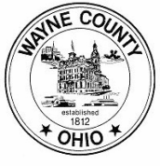

WAYNE COUNTY MUNICIPAL COURT
Personnel Changes 2022

● Joshua Summers was hired as a Court Security Officer/Bailiff on April 04, 2022.
● Joshua Summers resigned from his position as a Court Security Officer/Bailiff on
August 19, 2022.
● Robert Ecker resigned from his position as a Probation Officer on September 30, 2022.
● Noah Fetzer was hired as a Court Security Officer/Bailiff on December 19, 2022.

WAYNE COUNTY MUNICIPAL COURT
Bailiffs 2022

In 2022, the Municipal Court employed five bailiffs, two courtroom bailiffs and three court security bailiffs.

The courtroom bailiffs are responsible for security in the courtrooms, monitoring the daily courtroom calendars, and ensuring the proper function of the digital recording systems within the courtrooms. The security bailiffs are responsible for the security of the courthouse and all offices within the courthouse. Security bailiffs operate a metal detector and scanner at the front entrance, secure the building at the beginning and end of each business day, and are responsible for the operation and maintenance of the security cameras and video recording system.

In addition, all five bailiffs serve the process of the court. This includes personal service of summons and orders, eviction notices and actual set outs, and executions on personal property including conducting bailiff sales.

WAYNE COUNTY MUNICIPAL COURT

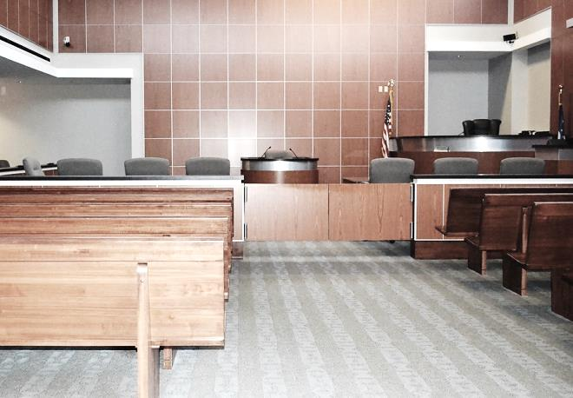
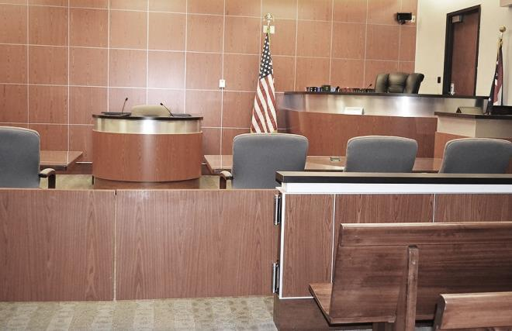
2022 Case Statistics

WAYNE COUNTY MUNICIPAL COURT
Cases Filed and Disposed 2022

Cases Filed 2021 2022

Criminal – Felony 6 5

Criminal – Misdemeanor 1,446 1,715

D.W.I. 288 322

Traffic 7,919 9,026

Civil 1,480 1,562

Small Claims 282 242

Total Cases Filed 11,421 12,872

Total Cases Disposed 10,057 11,384

* Cases disposed include waivers, defaults, pleas in court, and assignment to judge when not guilty plea (criminal, traffic) or answer (civil) is entered.

WAYNE COUNTY MUNICIPAL COURT
Cases Assigned for Trial 2022

Not Guilty Plea (Criminal – Traffic) or Answer (Civil)

2021 2022

Criminal – Misdemeanors 895 1,154

D.W.I. 207 222

Other Traffic 412 436

Civil-Small Claims 59 39

Total 1,573 1,851

Trials To Court

Criminal 43 35

D.W.I. 4 2

Other Traffic 37 59

Civil 0 0

Total 84 96

Jury Trials

Criminal 18 14

D.W.I. 6 1

Other Traffic 0 0

Civil 0 0

Total 24 15

WAYNE COUNTY MUNICIPAL COURT

2022 Payouts & Disbursements

WAYNE COUNTY MUNICIPAL COURT
Disbursements: Paid to Wayne County 2022

2021 2022

Paid to A13-N1 & A15-F1 555,240.37 654,951.96
Criminal-Traffic 217,175.98 233,483.71
Civil-Small Claims 114,367.15 215,592.05
OSP, State and Others 223,697.24 205,876.20

Paid to A13-G1 Housing/DUI 13,780.15 12,131.26

Paid to A13-S1 Restitution Fee 1,663.34 1,113.03

Paid to A13-Z1 Driving Privilege Fee 1,960 2,150

Paid to B18-A Diversion Program (Prosecutor) 8,550 5,400

Paid to B15-A1 Alcohol Treatment 18,714.36 18,659.59

Paid to B25-A1 Municipal IDIAF 11,434.64 10,659.60

Paid to K1-A3 Roads and Bridges 34,158.80 27,305.82

Paid to B1-A6 Dog and Kennel Fund 3,136.50 7,231

Paid to B16-A1 Education Fund 349.46 0

Paid to A42-C1 from sale of UTC 320 365

Paid to A45-O1 Misc. Reimbursements 655 0

Paid to B53-A1 Special Projects Fees* 142,127.30 157,678.20

Paid to B20-A1/A2 Computer Funds 132,524.69 143,546.99

Paid to B12-A1 Probation Fees 213,287.91 189,655.12

Paid to W35-A2 Indigent Application 8,204.70 7,808.74

Paid to A13-T1 Home Arrest Fees 59,504.70 70,185.25

Total $1,205,611.90 $1,308,841.40

*On August 1, 2019, the Special Projects Fund was created for Special Projects of the Wayne County Municipal Court pursuant to Ohio Revised Code Section R.C. 1901.26(B)(1).

WAYNE COUNTY MUNICIPAL COURT
Disbursements: Paid to State of Ohio 2022

2021 2022

Ohio State Patrol Fines 144,919.24 137,477.66

Victims of Crime 64,220.82 66,799.37

General Revenue* 0 0

Expungement Fees 2,280 1,560

Dept. of Liquor 3,929.43 1,613.35

Division of Wildlife 3,207.50 2,532.50

Legal Aid from Civil 37,661.69 39,457.02

Legal Aid from Small Claims* 3,049.20 2,602.71

Seat Belt Fines 41,811.93 57,559.89

Child Safety Fund 250 735

OSP Drug Fines 2,448.27 2,093

OSP Education Fund 4,855.27 4,648.25

Ohio Board of Pharmacy 9,678.52 8,002.45

Grant Refunds 11,490.12 0

BMV Fees 45 30

Totals $329,846.99 $325,111.20

Indigent Defense Support Fund $213,873.86 $220,170.66

$543,720.85 $545,281.86

* In 2010, per the Clerk of Courts, this account was consolidated into the Indigent Defense Support Fund (IDSF) for disbursements to the Treasurer of the State.
* On February 1, 2014, the Clerk of Courts assumed responsibility of the Small Claims Bank Account.

WAYNE COUNTY MUNICIPAL COURT
Disbursements: Drug Fines 2022

2021 2022

Creston 100 250

Chippewa Township 200 300

Dalton 425 200

Doylestown 0 250

Medway 100 0

Ohio State Police 0 0

Orrville 657.60 531.77

Paint Township 0 0

Rittman 152.83 1,035

Shreve 0 100

Smithville 0 0

Wayne County Sheriff 1,590.77 727

West Salem 100 0

Wooster 1,819.21 2,228.34

Village of Apple Creek 150 150

Total $5,295.41 $5,772.11

WAYNE COUNTY MUNICIPAL COURT
Paid to the Wayne County Law Library 2022

2021 2022

OSP Fines 72,330.98 68,836

State Fines 33,662.36 25,960.46

From Traffic 31,244.28 22,057.68

From Non-Traffic 4,800 4,800

Dept. of Liquor Control 1,200 1,200

Townships 5,668.01 10,276.08

Municipal Ordinances:

Wooster 1,300 1,300
Orrville 750 750
Rittman 150 150
Burbank 194 0

Totals $151,299.63 $135,330.22

WAYNE COUNTY MUNICIPAL COURT
Paid to Cities and Villages 2022

2021 2022

Wooster 26,783.25 29,845.08

Orrville 2,195 3,249

Rittman 6,646.05 8,120.95

Dalton 6,300.50 3,686.50

Apple Creek 1,695.65 204

West Salem 36 50

Mt. Eaton 712.50 88.50

Shreve 989.50 412.50

Smithville 30 486.65

Creston 175 135

Doylestown 54 40

Marshallville 0 100

Burbank 194 148

Fredericksburg 407.50 3,430.50

Total $46,218.95 $49,996.68

WAYNE COUNTY MUNICIPAL COURT
Disbursements: Other Fines and Fees 2022

2021 2022

Court of Appeals 750 875

Humane Society 150 478

Chippewa Township 5,260.53 6,808.31

Sheriff Fees 9,979.32 11,047.43

Wooster Police Fees 4,109.03 2,923.65

Creston Police Fees 184.50 405.50

Doylestown Police Fees 128.30 405

Orrville Police Fees 251.32 248

Dalton Police Fees 0 46

Rittman Police Fees 1,149.49 1,372.20

Smithville Police Fees 315.80 0

Shreve Police Fees 0 60

Apple Creek Police Fees 127 35
All Other Misc. Fees 1,016.58 461.93

Credit Card Fees 0 0

Totals $23,421.87 $25,166.02

WAYNE COUNTY MUNICIPAL COURT

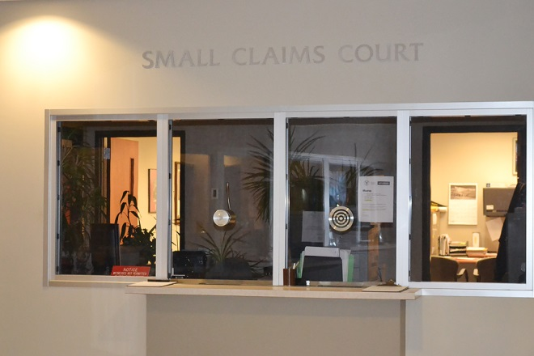
2022 Small Claims Court Statistics

WAYNE COUNTY MUNICIPAL COURT
Small Claims Court 2022

Small Claims Court handles monetary claims up to $6,000.00. All Small Claims cases are initially scheduled for a pre-trial mediation hearing. In 2022, there were 242 Small Claims cases filed. Twenty-nine (29) cases went to trial, resulting in an approximately 88% mediation settlement rate.

In addition to processing complaints, the Small Claims staff assists judgment creditors with post judgment collection actions. These include wage garnishments, attachments, executions on property and conducting judgment debtor exam hearings.

2022 filings by location:

Wooster 242

*Due to numerous reasons, on March 1, 2020, the Municipal Court ceased operating at its Orrville Branch.

WAYNE COUNTY MUNICIPAL COURT

2022 Probation & Home Arrest Statistics

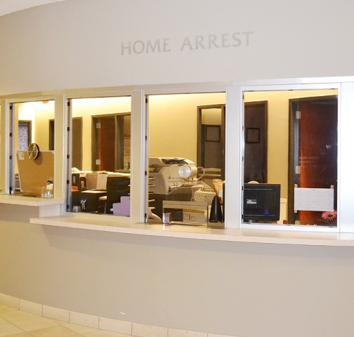
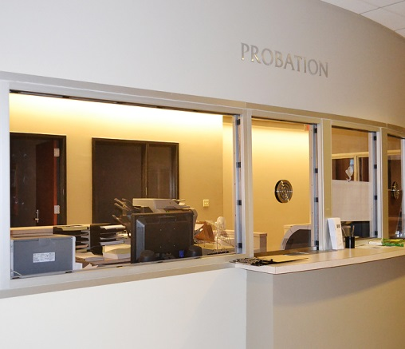

WAYNE COUNTY MUNICIPAL COURT
Probation Department 2022

2021 2022

Pre-Sentence Investigations 167 267

Placed on Probation 632 814
Released from Probation 765 929
Probation Violations 264 259
Expungement Investigations 121 87
Community Service Hours 519.33 3,030.12

Probation Fees Collected $213,287.91 $189,655.12

1st Offense DUI Program

Placed on Probation 76 134
Probation Violations 13 21
Released from Probation 66 89

WAYNE COUNTY MUNICIPAL COURT
Home Arrest Department 2022

2021 2022

Placed on Home Arrest 207 202

Number of Days Served 10,243 10,420

Number of Violations 16 6
Home Arrest Receipts

Total Paid to Wayne County $56,374 $112,748

Received from State CCA Grant* $225,496 $225,496

* The CCA 408 Electronic Monitoring Grant funds Home Arrest employees (salaries and benefits).

At the 2022 rate of $106.78 (the cost to house one inmate per day at the Wayne County Jail in 2022), the Home Arrest department saved a total of $1,112,647.60 in inmate per day, jail costs.

WAYNE COUNTY MUNICIPAL COURT
Disbursements: DUI Fines, Law Enforcement & Education Fund 2022

2021 2022

Wooster 970.60 661.72

Wayne County Sheriff 0 362.16

Orrville 133.64 155.67

Rittman 295 160

Dalton 19.45 25

Apple Creek 0 0

West Salem 95 0

Mt. Eaton 0 0

Shreve 50 0

Burbank 0 25

Smithville 25 35.99

Creston 34.60 56.66

Doylestown 127.57 85

Chippewa Township 281.15 85

Ohio State University 0 0

Total $2,032.01 $1,652.20

